Clerarance Stock

- Campus 20oz (Arc)
690 Dozen
A302CAM20GS
List 9.41 dozen
3 dozen to a box
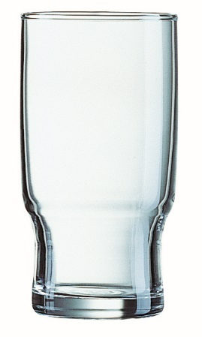

- New Worthington 12oz (Ravenhead)
270 Dozen
A103XWO12
List 11.69 dozen
3 dozen to a box
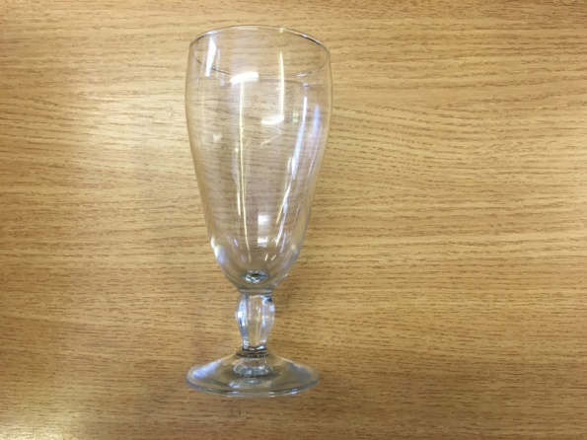

- Bar Master 12oz Beer Glass (Ravenhead)
120 Dozen
A102BAR12
List 10.53 dozen
3 dozen to a box
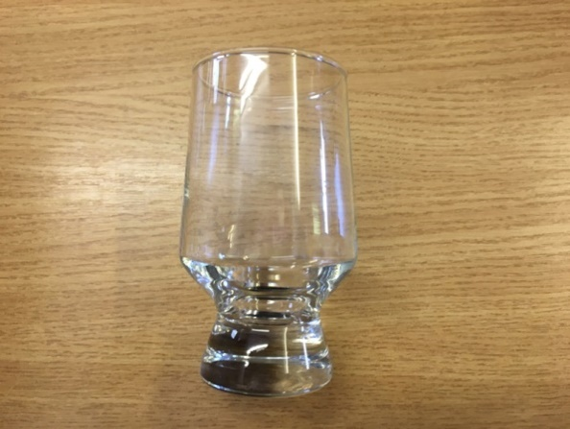

- Landlords Wine 7oz (Dema)
160 Dozen
A203LW108L
List 11.21 dozen
4 dozen to a box
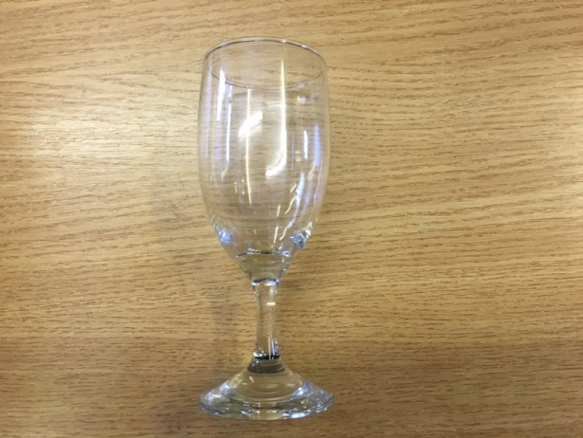

- Hamlet 6 2/3oz Wine (Dema)
80 Dozen
A203HAM07
List 11.32 dozen
4 dozen to a box
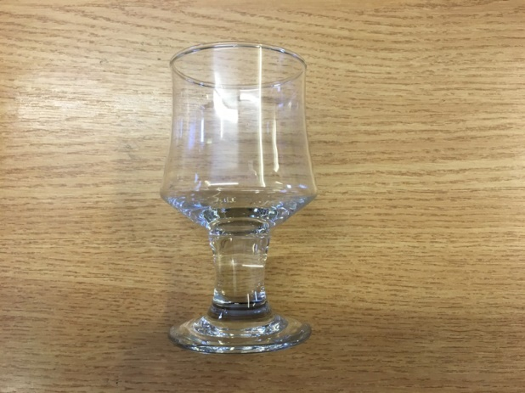

- Premier 20oz Beer Glass With Christmas Logo At Base (Dema)
74 Dozen
A208PRE20GSX
List 9.50 dozen
2 dozen to a box
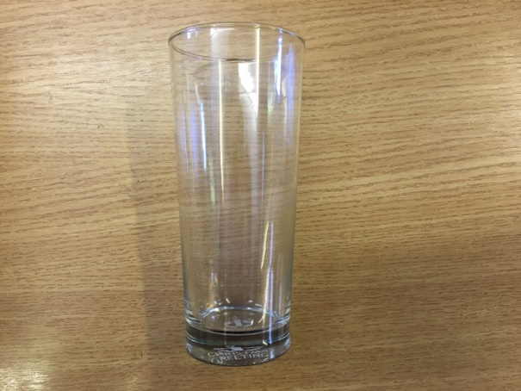
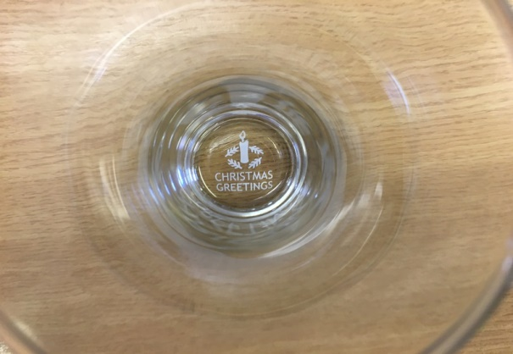

- Astor 12” Oval Dish Coupe (Steelite 1522-0142)
48 Each
I130ASTD12
List 10.01 each
12 to a box
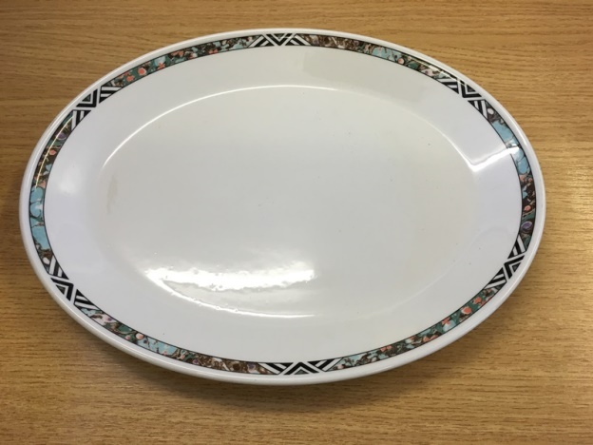

- Bordeaux Oatmeal Bowl 6.5” (Steelite 9103-C426)
108 Each
I130BOR06
List 4.81 each
36 to a box
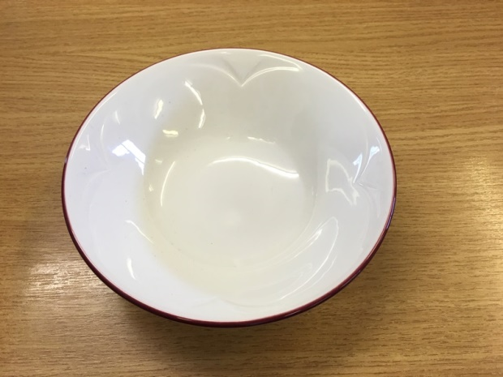

- 33/2ply Napkin Fresh Peach (Benders)
8 boxes of 2000
J133N332PF
List 34.61

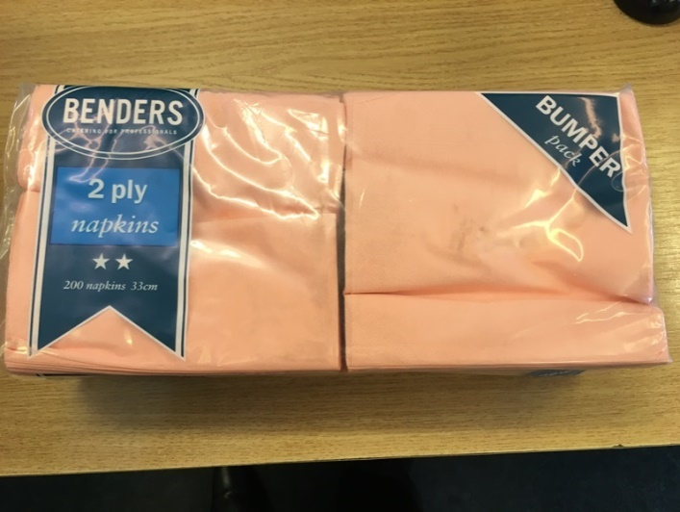

- 33/2ply Napkin Lavender Blue (Benders)
3 boxes of 2000
J133N332BL
List 34.61
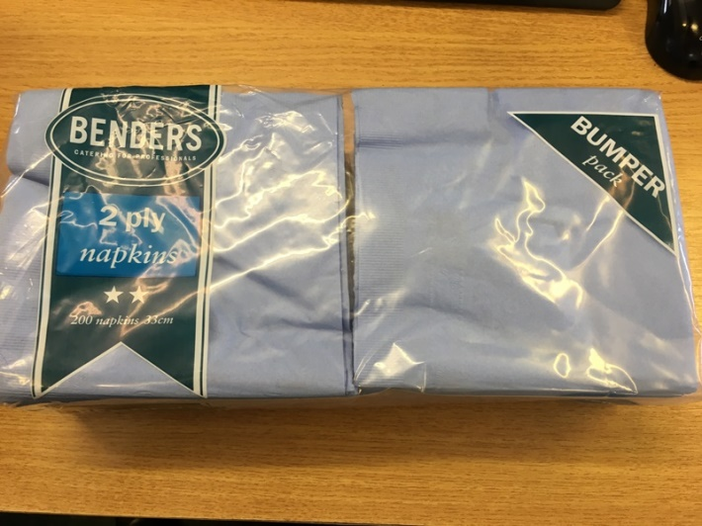

- Multi Mate Dispenser Napkin White (Benders 30 20002)
9 boxes of 4000
J133NM332W
List 74.60
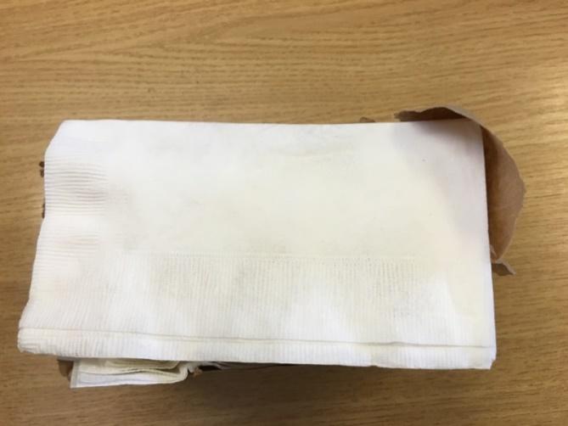

- Wypall L10 Barrel Roll White 2 ply (Kimberley Clark 7133)
17 cartons of 6 rolls
Q372WWW1
List 33.14
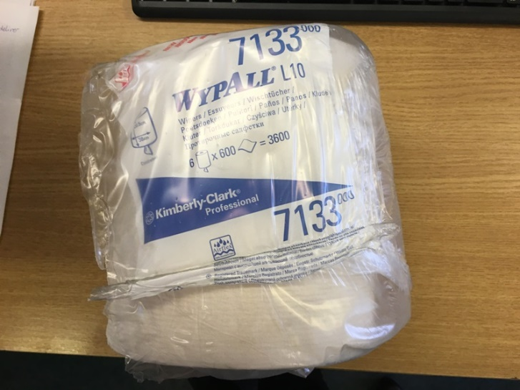

- Wentworth Coffee Spoon
117 Dozen
L932WSC
List 1.99 dozen

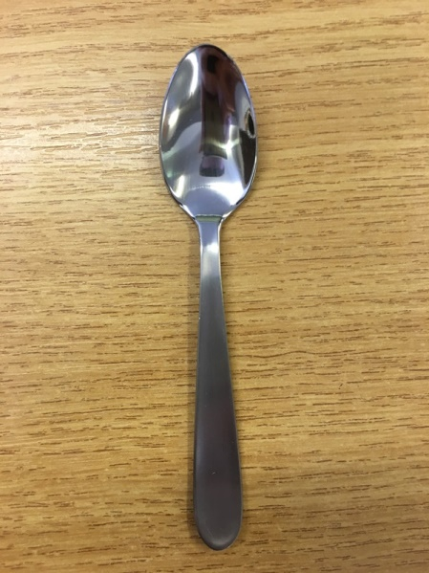

- Verwood Table Spoons
12 Dozen
L932VSTA
List 13.50 dozen
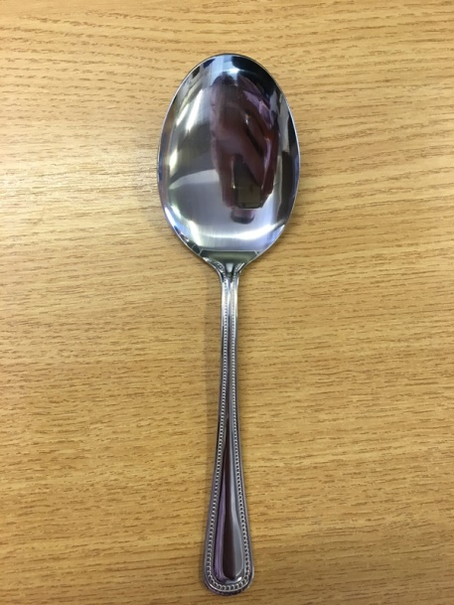

- Verwood Pastry Fork
15 Dozen
L932VFP
List 9.50 dozen

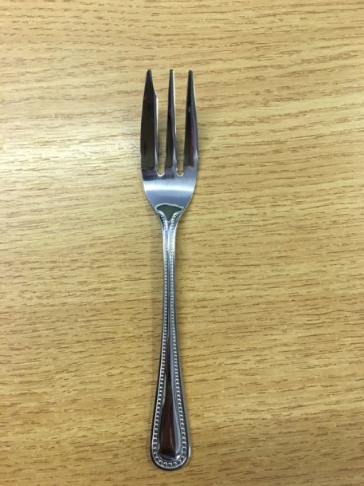

- Arc Black 4.5” Glass Ashtray A305R5BO4 (41471)
667 Each
A305RSB04
List 2.22 each
48 to a box
